**High School Graduation Rates:**

**Examining the Impact of Various Factors in the Washington D.C., Maryland, Virginia (DMV) Area, and New York State**

Carlotta Amaduzzi, Abou Keita, Jenell Lewis, Michaella Steinruck, Marissa Tan, Tim Van Wert, Jeneva Williams-Blackwell

Division of Professional Studies, University of Maryland Baltimore County

DATA602: Introduction to Data Analysis and Machine Learning

Dr. Tony Diana

December 10, 2021

**Abstract**

Graduation rates across the Nation have been flat despite abundant resources that policymakers, politicians, and stakeholders confirm are being dedicated to educational institutions. New York, Maryland, Virginia, and in particular the District of Columbia are examples of this continuing trend. Public resources are becoming more sparse and individual States are being asked to plan for concrete improvements in their ability to form the workforce of the future or face cuts in Federal funding. So, it is imperative to understand better what elements affect educational outcomes the most. In this paper, the effect of financial resources, manpower, and student composition on the 2018-2019 graduation rates was analyzed by exploring the adjusted cohort graduation rates for New York, and the Washington D.C., Maryland, and Virginia area (DMV). The results confirmed that free and reduced lunch, funding, reading and math assessments, student-teacher ratio, and students’ race and gender affected graduation rates.

**High School Graduation Rates: Examining the Impact of Various Factors in the Washington D.C., Maryland, Virginia (DMV) Area, and New York State**

Education is a multifaceted and multidimensional topic. It is at the center of most societies and is often used as an element to evaluate the health of a country and its long-term development potential. It is no wonder that education is such an important issue of debate, whether in private circles or the public arena. Politicians use education as a tool to sway public opinion, and policymakers view education as central to public debate, which requires the cyclical demand of in-depth research on its status and its ailments. However, determining how to measure the success of an educational system is not straightforward. There are many different lenses we can choose to view the effectiveness of an educational system through, and usually choosing one measure over another can illustrate an educational system quite differently, thus serving different purposes for politicians, policymakers, or other stakeholders.

A measure often used to showcase the effectiveness and health of an educational system, especially when focusing on compulsory education (i.e., the portion of education that is set to be mandatory for a society’s people), is the rate at which students are successful in completing this mandatory round of studies, given the acceptable minimum standards (i.e., the expectations) set by society.

Federal funding in education was first implemented through the Elementary and Secondary Education Act (ESEA) of 1965 by President L.B. Johnson, as part of his “War on Poverty” agenda. The 2001 reauthorization of ESEA, known as No Child Left Behind (NCLB), under the Bush administration, allowed individual States to use graduation rates to evaluate their educational systems’ performance on either a yearly basis or at the end of ten years. In 2015, President Barack Obama reauthorized the law as the Every Student Succeeds Act (ESSA) (Paul, 2016) to continue to enhance schools’ performance and accountability to receive federal education funding. While this act encourages States not to focus solely on graduation rates to evaluate their educational system’s performance, it requires States to set goals for all students as well as subgroups (unlike NCLB) and to report schools with graduation rates below 67% as low performing (Achieve.org, 2018: 1).

Education is viewed as a fundamental right and included in the Universal Declaration of Human Rights adopted in Paris in 1948 by the UN (article 26, United Nations, 1948), however, societies have quite a wide leeway in determining where to set these standards. These minimum standards, which effectively determine the minimum knowledge base that is considered acceptable to become productive members of society, tend to be revised by societies over time both in terms of content and in terms of requirements (OECD, 2021).

In the US, the minimum standards are primarily set at the State level. Requirements are set in terms of students’ ages as well as number of credits by subject matter, and minimum number of school days per academic year (NCES, 2020). “Well-articulated goals serve numerous critical purposes, including clarifying the State’s aspirations and priorities for its students, schools, and the future of the State more broadly; focusing policy, practice, and resources on the most effective strategies to achieve their goals; and signaling the need to adjust course along the way if a State is not meeting its trajectory” (Achieve.org, 2018: 1).

The Federal Government participates in promoting and supporting education across the United States by (1) setting a framework of priorities States are encouraged to adhere to, equitably, across their populations; (2) by disseminating information about priorities and programs open to the States to pursue; and (3) by providing direct program funding across grade levels. The Federal Government’s funding and involvement in education have evolved in parallel with significant societal challenges, such as the need to train and educate veterans from World War II[1], the race to enhance the prestige and protection of the country against potential foreign challengers[2], or the interventions of the ‘60s and ‘70s aimed at protecting equal access to education to all members of society following the Civil Rights movements and more.

With our work, we set out to look at graduation rates for the States of New York, on the one hand, and Maryland-Virginia District of Columbia on the other hand, for the academic year 2018-2019. In particular, we intended to analyze which (among a subgroup) of the publicly available independent variables recorded by the National Center for Education Statistics (NCES) appear to influence students’ graduation rates to help States identify measures upon which to build realistic improvement plans for their education systems. Our hypothesis is that free and reduced lunch programs, public funding, reading and math assessments, student-teacher ratio, and students’ race and gender composition, directly affect graduation rates.

**Literature Review**

In 2016, the percentage of 18- to 24-year-olds not enrolled in high school or a lower education level who held a high school diploma or an alternative credential, such as a GED, was higher for females (94.3%) than for their male peers (91.6%)[3]. “Between 1976 and 2016, the status completion rate for male 18- to 24-year-olds increased from 83.0% to 91.6%, and the female status completion rate increased from 84.0% to 94.3%. Between 2006 and 2016, the status completion rate increased from 86.5% to 91.6% for male young adults and from 89.2% to 94.3% for female young adults” (McFarland et al., 2018: 36). These increases in graduation rates seem promising and offer an improving picture of the state of our educational system. Yet, when we take a closer look at the data, taking into consideration public schools’ funding, dropout rates, teachers’ and administrative staff’s increases, as well as students’ overall performance, the impression we get is quite different.

Federal funding has increased over the years, even if it “has never provided more than 13 percent of school funding, and today it is responsible for less than 10 percent” (Chingos M. & Blagg K., 2017: 1) Researchers agree that there has been a “real increase in current spending per student in public K-12 education— from $900 per student in 1929-30 to $8,765 in 1999-2000—an increase of 873.9%. [and] … the increase in real public-school spending per student was more than three times the increase that occurred in higher education over these 70 years” (Scafidi, 2016: 7). During these same years, according to data from the National Center for Education Statistics, the number of full-time employees working in education also increased significantly (Scafidi, 2016). Finally, taking into account the fact that dropout rates are under-accounted for when using graduation rates as measures of high school success and that “Nearly half of Black and Hispanic kids [still] drop out of school before they graduate” (Bolick, 2017: 1), there is agreement that there is a problem: as States are encouraged to become more cognizant of their educational outcomes, set goals in terms of graduation rates, and receive greater funding (both at the State level and from the Federal Government) for education, the increases in graduation outcomes, as measured by graduation rates, are not significant, if present at all. (Scafidi, 2016).

The data indicating higher numbers of teachers into the system in parallel to greater funding has led some to conclude that students must have become harder to teach. However empirical studies failed to confirm this is the case and went further, indicating that “Student disadvantages that impede learning declined by 8.7 % between 1970 and 2000” (Scafidi 2016: 4). Greene and Forster (2004) conducted a study across the states using a comprehensive measure of students’ teachability and confirmed that students’ teachability did not decrease. The researchers went on to conclude that “States with more school choice or stronger accountability testing demonstrate better school performance” (Greene and Forster 2004: 1). Two of the states in our sample are among those that performed worse on these criteria. These are New York and the District of Columbia. When nearly one in five young people fail to graduate high school on time, there is a “substantial economic, social, and civic cost to the individual and society” (Zaff et al., 2017: 467).

Given the state of expenditures and the current levels of graduation rates, we may question the effectiveness of the education system. If we consider the combined effect of increases in spending with increases in teaching staff and a relatively stable “teachability of students” (Greene & Forster 2004), we can raise the question of whether teacher effectiveness may be at play. This important issue is not new and is often used to propose rerouting of public funds towards programs intended to increase teacher effectiveness. Yet, some believe that the combination of an increase in less experienced teachers entering school systems and an increase in bureaucratic demands placed on teachers may have led to decreasing results.

Teacher effectiveness is sometimes measured in parallel to the students-to-teachers ratio and students-to-teachers relationship (STR). STR stems from data collected from students’ beliefs in teachers’ abilities, expression of concern for their well-being, and interest in their success (Zaff et al., 2017). Because “School-level risk factors such as teacher quality” have been shown to predict young people leaving school before graduation, the importance of analyzing these measures goes without saying (Zaff et al., 2017: 449). However, just keeping students from dropping out does not guarantee timely graduation nor one that sets them on a path to success (Robison et al., 2016). The societal burden placed on teachers only gets larger especially since the youth-teacher relationship shows “consistent, direct predictive effects on graduation and continued enrollment" (Zaff et al., 2017: 469).

One of the possible solutions suggested to reverse this continuing trend in graduations and try to make schools and teachers more effective has been to recommend the transformation of schools into enterprises of sort, directly owned by teachers, staff, and the principal working there (Veeder as referenced by Scafidi, 2016). This approach would ultimately lead schools to compete for students and thus direct funding via some form of a voucher program. While somewhat extreme, this type of solution has been gaining ground recently with many recommending the greater transfer of school choice control in the hands of students and families. Giving greater control in the hands of the “consumers” of education, it is argued, would lead to greater efficiencies and greater pressure to perform on the school system, ultimately leading to improvements for all stakeholders involved. However, little evidence has been given on the effects such transfer of power may have on the educational institutions long term.

Recent evidence of this type of program comes from the Opportunity Scholarship Program (OPS), which was adopted by Congress in 2004 through the DC School Choice Incentive Act and implemented by the District of Columbia’s school system. OPS is a voucher program that provides a limited number of DC families up to $7,500 that they can use towards choosing their children’s education. The program was adopted in part to test if it might lead to higher efficiencies inside the school system by providing “public schools with an incentive to improve their performance by increasing market competition in education” (Greene & Winters, 2006: 9). However, it has produced “no academic effect, positive or negative, on the District's public schools after its first year” (Greene & Winters 2006: 4).

To monitor the performance of education, some of the states adopted “graduation exams”. In 2020 there were only 11, among which Maryland, New York, and Virginia. These exams attest to students’ basic level of academic proficiency as a prerequisite to attending higher education institutions. Many critics of these tools suggest that these exams lead to higher dropout rates, in particular for lower-income students, basically depressing the already low performance of schools. Greene and Winters (2014) conducted a study that directly challenges these assertions. However, poverty has a strong and lasting effect on academic achievement, not just directly on students’ ability to learn, but also indirectly when it becomes an additional stressor against effectively completing their education (Robison, et al., 2016). The connections existing between poverty and graduation rates have been studied. Strong positive correlations were found between failing a grade or being expelled, and receiving free or reduced lunches (as a proxy for poverty) or dropping out of high school, with prior school expulsion being one of the most significant predictors for the unsuccessful four-year graduation term (Robison, et al., 2016 ). Furthermore, some researchers attributed lower outcomes to depressed achievement motivation, which is linked to academic success and is influenced by the culture surrounding the student (University of Maryland School of Social Work et al., 2019).

In 2016, the dropout rate was higher for males between the ages of 16- to 24-year-olds than for females between the same ages (7.1 % and 5.1 % respectively). Researchers saw an optimistic downward trend in the overall dropout rate for both males (from 14.1 to 7.1%) and females (from 14.2 to 5.1%) who were between the ages of 16 to 24 from 1976 to 2016 (McFarland, et al. 2018: 15). At the same time, a gender gap in graduation rates was also observable with females more likely to graduate than male counterparts, which is evident within minority groups (Robison et al., 2016).

Research by Heise (2019) using publicly available data from 2016 suggests that even in the presence of high public financing of Title I schools graduation rates remain depressed, especially for lower-income students, because a “student poverty penalty persists and is robust to multiple per-pupil spending” analyses. In other words, schools with a higher proportion of students in need, even when they receive greater funding, experience a “financial penalty”, which may be caused by “traditional reliance on local property tax revenues for elementary and secondary public school finance, or variation across states and school districts in how Title I [funding] is administered” (Heise, 2019: 3). One can infer that despite great financial disbursements by state and federal resources, there still is a persistent problem. In fact, according to some sources, minority students experience poverty at two to three times high rates than White children (University of Maryland School of Social Work et al., 2019).

There is a tradition in US education to keep school financing closely linked to local decision-makers – so-called “local control” of funding. Local control ideally has the benefit of ensuring a closer connection with local communities and – ideally- potentially better effects (returns on investments) on the funds spent. However, at the same time, especially in lower-income communities this link may be – at least in part – cause for the poverty penalty so many Title I schools experience given the fact that the local communities they serve are also those who are least able to contribute significant funds to support their schools and other services. Furthermore, “state operating environments and policymakers appear to have a fairly strong influence on their within-state LEA [Local Education Agency] level instructional spending patterns when reported as per-pupil dollars and controlling for LEA characteristics” (De Luca 2019: 10). When considering “a school district's percentage of students in poverty [then] … as a crude proxy for a district's broader fiscal strength” (Heise, 2019: 9), one may grow further concerned by the lack of effectiveness that public funding seems to have on education. Even when considering financial resources in various manners such as “total per-pupil revenue, total current per-pupil spending, and total current per-pupil instructional spending” (Heise,2019: 5) the results appear to be consistent although as the researcher himself admits this may be due to the intercorrelation existing between these measures.

**Methods and Results**

To conduct the analysis, the DMV area was aggregated to achieve a better comparison with New York by reaching comparatively more similar aggregates of school data. This is because NY State’s school system is one of the largest in the country, alongside California and Texas. We also briefly analyzed national data for comparison purposes.

We merged several data sources upon which we built our analyses. The four datasets included (1) descriptive variables such as School ID and location, teachers-to-students ratios, whether the school is a Title 1 school (i.e., whether the school receives federal funding), number of students reported receiving free and reduced lunch, total student enrollment numbers by grades and ethnicity, etc.; (2) data on graduation rates and cohort counts by major ethnic group, etc.; (3) financial information (i.e. data on the funding schools received); and (4) data on the number of students who successfully passed their high stakes math and reading tests in high school. From these datasets, we decided to focus our analysis and modeling on graduation rates in connection to totally free and reduced lunch students, race, student-teacher ratio, gender, number of students passing math and reading assessments, and funding to reveal which among these seem to affect graduation rates the most and which help predict successful completion of high school based on the 2018-2019 academic year data.

For the success rate/graduation rate, the threshold of 67% was used since this is the minimum level that was set by the ESSA legislation as a low-performance marker in connection to Federal funding disbursements. An integer of one was assigned to any value above and equal to 67%, and 0 for any value below 67%. After cleaning the data and conducting exploratory data analysis, we created visualizations for the variables of interest listed above.

**Free and Reduced Lunch**

**Fig. 1** *Average Percentage of Free and Reduced Lunch Students by Graduation Rates Category*

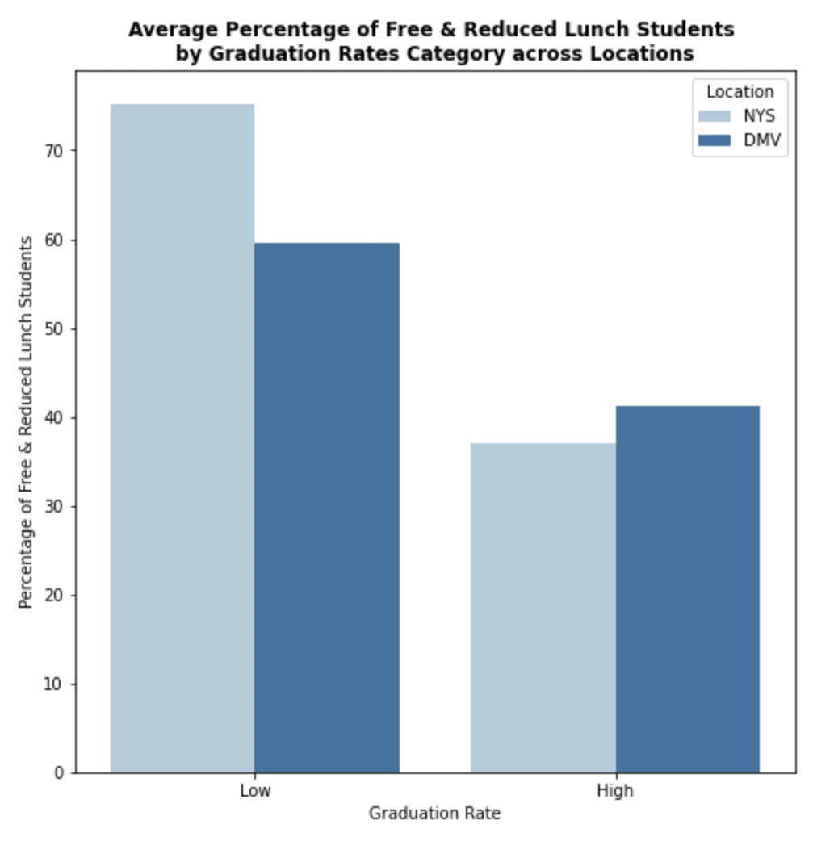

We compared the average percentage of students who receive free and reduced lunch by the success rate categories across the two locations we are focusing on: the DMV area and New York State. Fig. 1 displays this information in the form of a bar chart. We observed that the average percentage of free and reduced lunch students is higher for schools with lower graduation rates compared to schools with higher graduation rates, regardless of location.

**Race**

We evaluated the differences in graduation rates between racial cohorts across both locations. Two aggregated racial groups were created: White and Minority. Minority included American Indian/Alaskan, Asian/Pacific Islander, Black, Hispanic, and Multiracial students. The computed correlation between White students and graduation rates in both the DMV and New York State is positive. This indicates that as the number of White students increases in a cohort, the graduation rate does too. In contrast, there is a negative relationship between the number of minority students and graduation rates in both the DMV and New York State. The data, in other words, confirm that as the number of minority students in a cohort increases, the graduation rate decreases. This data is represented in Fig. 2. The results showing the opposite relationship between White graduation rates and Minority graduation rates confirm previous research. Minorities in the state of New York have a lower graduation rate compared to their White counterparts. The DMV area shows a more competitive and similar result due to schools being more diversified.

**Fig. 2** *Racial Cohorts by Graduation Rate*

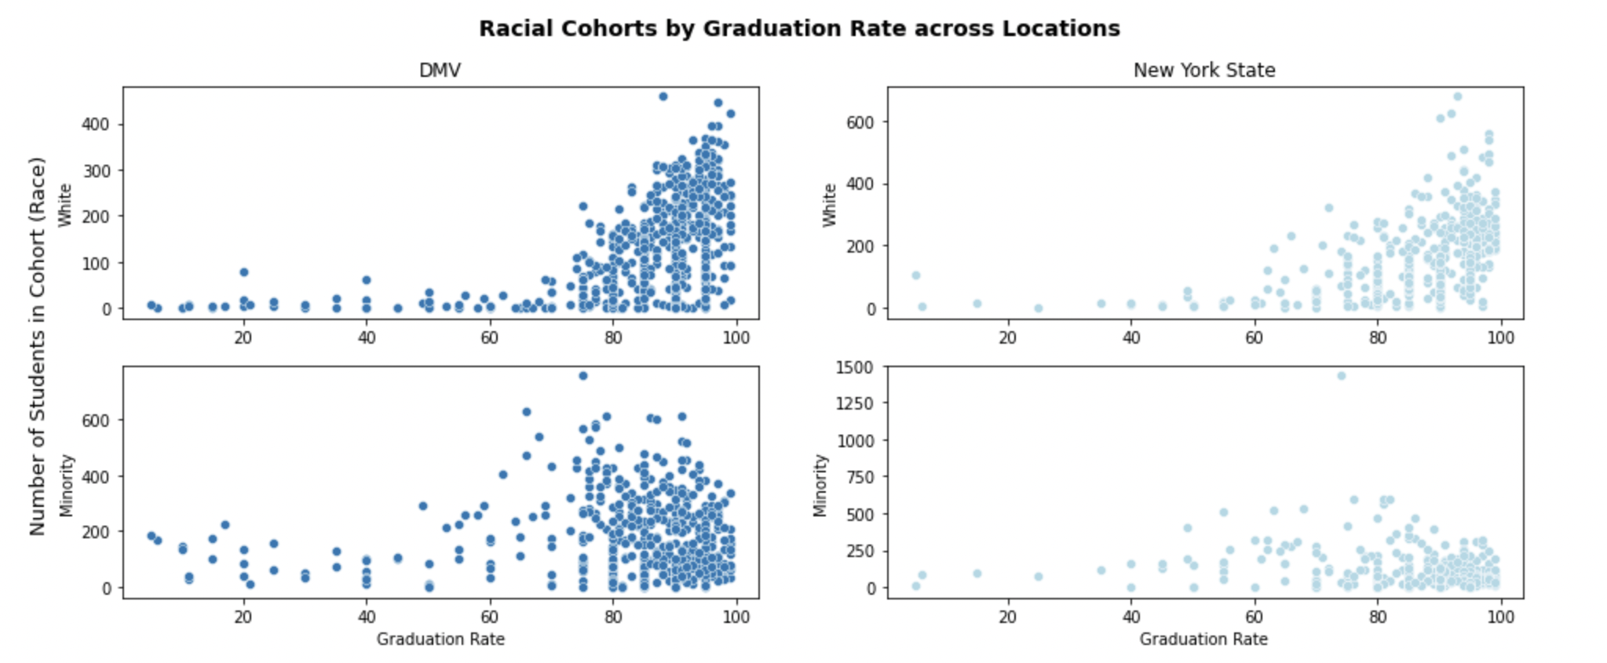

**Student-Teacher Ratio**

**Fig. 3** *Student-Teacher Ratio by State in Ascending Order of Average Graduation Rate*

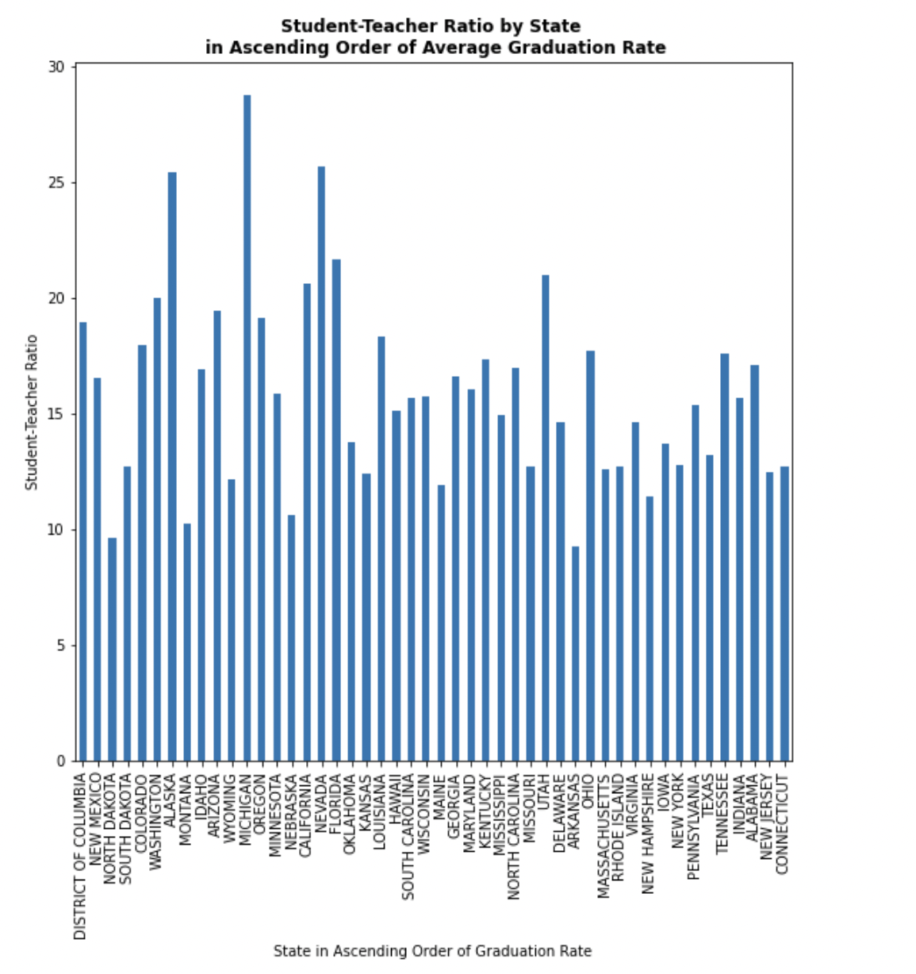

We examined the relationship between student-teacher ratio and average graduation rate across all States, which are sorted in ascending order across the x-axis. The bar chart visualization is presented in Fig. 3. We also computed the correlation between the two variables and found that there is a negative correlation between the student-teacher ratio and the average graduation rate, meaning: as the student-teacher ratio increases, the average graduation rate decreases. This result seems to confirm previous findings as well.

**Gender**

We compared the differences in graduation rates between the percentage of students who fall within the two gender cohorts, male and female, across both locations. The scatterplots are displayed in Fig. 4. The result is that there is a negative correlation between graduation rates and the percentage of male students in the student cohort, regardless of location. In comparison, there is a positive correlation between graduation rates and the percentage of female students in the student cohort, regardless of location, again confirming previous researchers’ findings.

**Fig. 4** *Percentage of Students in Gender Cohorts by Graduation Rate*

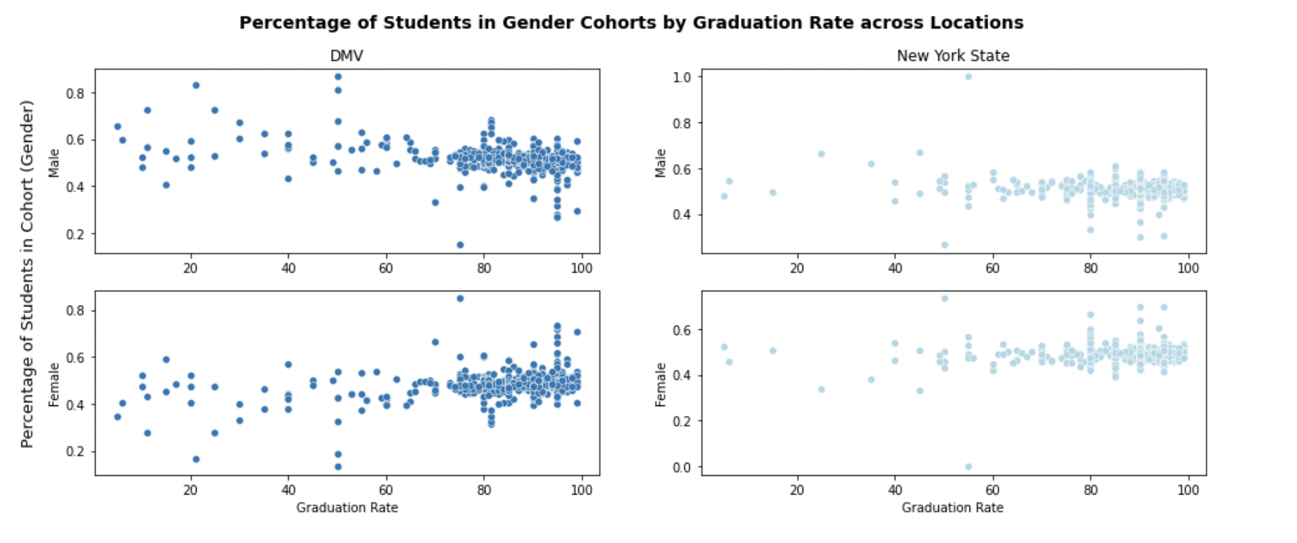

**Funding**

The last variable we examined is the total current spending per student by Title I eligibility status, which is visualized in Fig. 5. In the DMV area, schools that qualify for Title I are given more money per student than those that do not (see Fig.5a), however, this is not the case for New York State (see Fig.5b), at least for the 2018-2019 academic year. Both Title I eligible schools and schools that are not Title I eligible received approximately the same amount of funding per student.

**Fig. 5** *Current Spending Per Pupil by Title I Eligibility in the DMV Area*

**Fig. 5a DMV Area** **Fig. 5b New York State**

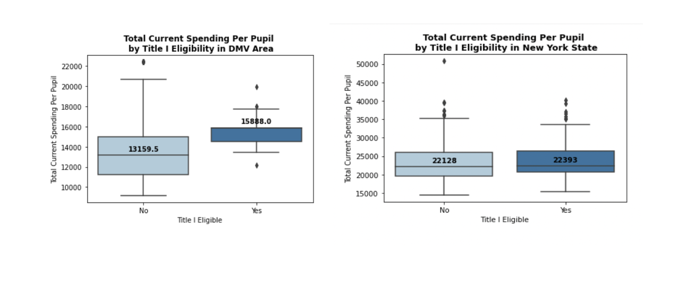 

The first four out of five of our visualizations confirm the results found by researchers that were referenced earlier. Fig. 5 shows that Title I eligible schools receive more funding, despite location. It does not confirm nor deny the findings of the 2011 U.S. Department of Education study that a significant portion of Title I eligible schools receive less funding than their non-eligible counterparts. The scope of the results was nationwide, and we focused only on the DMV area and New York State. Furthermore, we did not check these findings in parallel to the number of students in Title I eligible schools who also are classified as Special Education students, nor did we control for the presence of special programs in those schools, such as Magnet Programs, which tend to increase the amount of funding received.

**Algorithms**

As far as modeling is concerned, we used regression and classification models on all features, except Title 1. To find the optimal model, we ran an initial analysis using Lazypredict (a Python library that simplifies initial data analysis) on the data (Dey, 2021). For the regression models, we used the ALL_RATE feature, which is continuous and measures the number of students successfully completing high school, as our dependent variable. For the classification models, we used Success_Rate which is the ALL_RATE feature transformed into successful/not_successful based on the graduation rate threshold (67%). An unsupervised model was also used to find clusters within the data and then the silhouette score was computed to find the best number of clusters for the data. Although the dataset was quite small to run a Neural Network (NN), we ran a NN model to check for any improvements in the accuracy scores compared to the previous models. From Lazypredict, the Lazy Classifier (using the categorical variable) performed better than the Lazy Regressor (using the ratio variable) in both the New York and DMV datasets. A few classification models were chosen based on performance and one regression model was chosen for each.

**Regression Models**

The regression models for NY and DMV did not perform well in lazypredict. Gradient Boosting regression was one of the top-performing models for both regions. The NY data had a score of 46% and the DMV data had a score of 69%. Therefore, the DMV data did better at predicting graduation rates. However, when we compared our analyses between the test scores and train scores, we found that the train scores were significantly higher than the test scores, suggesting that the models were overfitting the data. To help prevent overfitting in the future, cross-validation or regularization can be performed on the models.

**Classification Models**

***LinearSVC***

**Fig. 6** *ROC Graphs of LinearSVC on NY and DMV datasets*

**New York State DMV Area**

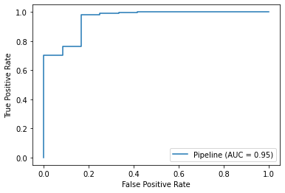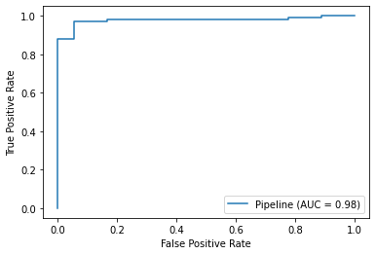

A classification report was generated for LinearSVC to see how well the model performed. For both NY and DMV, the precision, recall, and F1 score were high for class 1 (successful completion) and fairly high for class 0 (unsuccessful completion) with scores between 75% and 87% (see Appendix - Fig. 1A). The recall results indicated that 75% of NY students and 94% of DMV students who truly failed were predicted to fail, and 97% of DMV students and 98% of NY students who truly graduated were predicted to graduate. Therefore, both have high accuracy scores (97%).The Receiver Operating Characteristics (ROC) curve was created to check how well the model did at predicting classes correctly and a high Area Under The Curve (AUC) for the ROC curves confirms this. In this case, DMV performed better than NY because the AUC score for DMV was 98% compared to 95% for NY (see Fig.6). Finally, a confusion matrix was created for this model (see Fig.7). Most of the values in the confusion matrix for both DMV and NY are in the True Positive quadrant, followed by the True Negative quadrant again confirming that the model did well at predicting correct values.

**Fig. 7** *Confusion Matrix for LinearSVC on NY and DMV datasets*

**New York State DMV Area**

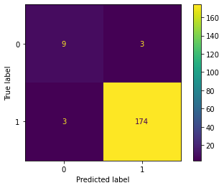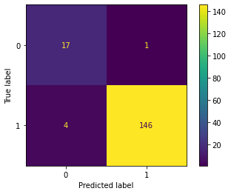

***Random Forest***

Random Forest was performed on the data to compare the performance of an ensemble model to a regular classification model. Random Forest had the same accuracy score as LinearSVC for NY (97%). However, it performed slightly worse (94%) than LinearSVC for DMV. So, NY’s data did better on the Random Forest model. Feature importance graphs were also generated from the Random Forest model. (see Appendix - Fig. 2A) For both NY and DMV, the READ_PCT was the most important feature, and then the importance deviated. The least important feature for NY was MATH_NUM (number of students successfully completing high school math assessments), surprisingly, and for DMV, it was the MAM_COHORT (the cohort of American Indian/Alaska Native students). This means that the reading assessment was the most relevant feature for classifying the success rates in this model.

***Logistic Regression***

We also ran Logistic Regression on the data and we found that NY and the DMV had comparable scores (98% compared to 97%). The model performed approximately the same as LinearSVC and Random Forest for NY but did slightly better than Random Forest for the DMV area. The Logistic Regression was done with ‘grid_searchcv’ which is a library in sci-kit learn that tunes hyperparameters and the penalty used was l2 (ridge), so the best results along with the best parameters were computed.

***Ridge and Lasso vs. Logistic Regression***

Furthermore, we ran Ridge and Lasso with a Logistic Regression model to see how they affect the R2 score. Both NY’s and DMV’s R2 test Score diagrams are almost identical for the Logistic Regression and Lasso models (see Appendix - Fig. 3A). Lasso runs evenly along the y axis at 0, while Logistic Regression runs smoothly along the y axis at 1 as the number of iterations increases. However, the R2 line of DMV’s Ridge runs erratically between 1 and- 1.25 as the iteration increases while for NY’s Ridge is between 1 and -0.6. We attributed this erratic movement of the Ridge regression to its process of shrinking the coefficients close to zero. On the other hand, we attributed Lasso’s to its ability to successfully drive the coefficients of the least important features towards zero.

***Neural Networks***

The Neural Network (NN) for NY shows a test score (loss) of 85% and a test accuracy of 96%, while for DMV it shows a test score of 15% and a test accuracy of 95% (see Appendix - Fig. 4A ). The NN accuracy result was the lowest for the NY classification models and it was the third-highest for the DMV models. As mentioned above, the data set was small and not conducive to running a NN model, but the result for DMV showed an improvement in the accuracy score compared to Random Forest. (see Appendix - Fig. 4A)

***Clustering***

A graph of silhouette scores was calculated for the cluster analysis (see Appendix - Fig. 5A). We chose k values of 2, 3, and 4. For the NY and DMV clusters, k = 2 offered the highest silhouette score of the three clusters, with NY performing better than the DMV’s. This means that k = 2 did the best at having distinct clusters, and thus there are two clusters in both the NY and DMV datasets. This could indicate that schools in the metro area are distinctly different from those outside the metro area; further research would be warranted.

Overall, we found that the regression model performed better on DMV than NY, and classification models performed slightly better on NY than DMV. For the classification models, all the accuracy scores were above 94% which means that the chosen features performed well at classifying the success rates. Therefore, we concluded that these features had an impact on graduation rates in 2018-2019 and we were able to confirm previous research results. It is important to note that there was a class imbalance with the classification target variable because there were a lot more successes than failures in the dataset. In the future, to alleviate this issue, we will try to either use a larger dataset that is more balanced or try to set the threshold at another reasonable value.

**Final Remarks**

We explored education data centered on the adjusted cohort graduation rates for New York and the DMV area for the school year 2018-2019. The analysis was centered on verifying which school characteristics (among a selected few) had an impact on graduation rates and which had the most significant potential to predict success/failure in school. As expected, schools with a higher numbers of students in the ‘free and reduced’ lunch program and with higher student-teacher ratios, had also lower graduation rates. In addition, minorities and males tended to affect downwards graduation rates as well. Finally, most of the characteristics performed well in the classification models, where the reading assessment was one of the most important features in successfully classifying school completion. However, our results are just an initial step. Further research is warranted to verify whether Title I schools present diversified characteristics and whether their graduation rates were affected by the presence of confounding variables, such as Magnet programs or high numbers of special education students. Furthermore, it would be interesting to verify whether these features affect rural versus metropolitan area school districts similarly and whether similar results can be observed across the nation. Certainly, there is a challenge posed by the data collected across states and districts since publicly available data in education often does not lend itself to straightforward comparisons across or within States. Regardless, future data science research will prove to be an invaluable tool to assist our better understanding of graduation rates, but especially to assist States in planning for their, and the Nation’s, long-term growth.

**References**

Achieve.org (2018, February). Thinking Long Term State Graduation Rate Goals under ESSA https://www.achieve.org/files/sites/default/files/ThinkingLongTermGraduationRateGoalsUnderESSA.pdf

Bolick, Clint. (2017). Jump-Starting K-12 Education Reform. *Harvard Journal of Law & Public Policy*, Vol. 40, no. 1, pp. 17–24. EBSCOhost. http://www.harvard-jlpp.com/wp-content/uploads/sites/21/2017/03/Bolick_FINAL.pdf

Business Roundtable. Essential Components of a Successful Education system https://www.businessroundtable.org/archive/resources/essential-components-of-a-successful-education-system

Chingos M. and Blagg K. (2017). Do poor kids get their fair share of school funding? <https://www.urban.org/sites/default/files/publication/90586/school_funding_brief.pdf>

Chingos M. and Blagg K. (2017) How Has Education Funding Changed Over Time? Urban Institute https://apps.urban.org/features/education-funding-trends/

Comunale, C. L., Higuera, M. S., Sexton, T. K., & Stickle, K. (2021). Performance Targets for School Districts. *Educational Research Quarterly*, *44*(3), 61–91. https://eric.ed.gov/?id=EJ1302152

DeLuca, T.A. (2018). Instructional Spending Metrics: A Multilevel Analysis Using NCES Data. *Journal of Education Finance* 44(1), 23-44. https://www.muse.jhu.edu/article/721594

DeLuca, T. A. (2015). Do Countywide LEAs Allocate Expenditures Differently from Community-centric LEAs? Evidence from National Center for Education Statistics Common Core Data. *Journal of Education Finance*, 40(3), 222–252. http://www.jstor.org/stable/24459481

Dey V. (2021). Visualizing and Comparing ML Models Using LazyPredict. https://analyticsindiamag.com/visualizing-and-comparing-ml-models-using-lazypredict/

Fairtest. (2019). Graduation Test Update: States That Recently Eliminated or Scaled Back High School Exit Exams https://www.fairtest.org/graduation-test-update-states-recently-eliminated

FindLaw's team (2016, June 20). Compulsory Education Laws https://www.findlaw.com/education/education-options/compulsory-education-laws-background.html

Great Learning Team (2020). Random forest Algorithm in Machine learning: An Overview. https://www.mygreatlearning.com/blog/random-forest-algorithm/

Greene, J.P., & Forster G. (2004). The Teachability Index - Can disadvantaged kids learn? *Education Working Paper* 6. https://media4.manhattan-institute.org/pdf/ewp_06.pdf

Greene, J. P., & Winters, M. A. (2006). An Evaluation of the effects of DC's voucher program on public school achievement and racial integration after one year. *School Choice Demonstration Project.*<https://scholarworks.uark.edu/scdp/26>

Greene, J.P., & Winters, M.A. (2004). Pushed Out or Pulled Up? Exit Exams and Dropout Rates in Public High Schools. *Education Working Paper* 5 https://files.eric.ed.gov/fulltext/ED483336.pdf

Heise, M. (2019). Per Pupil Spending and Poverty's Persistent Penalty: An Empirical Analysis of 2016 District-Level NCES Data. *Journal of Education Finance*, *45*(2), 149-171. https://link.gale.com/apps/doc/A621087584/LT?u=rock77357&sid=summon&xid=e8ccbbaa

HISTORY.COM Editors (2010). G.I. Bill. https://www.history.com/topics/world-war-ii/gi-bill

Kesumawati A. & Tri Utari D. (2018). Predicting patterns of student graduation rates using Naïve Bayes classifier and support vector machine. *AIP Conference Proceedings 2021*, 060005. https://doi.org/10.1063/1.5062769

Linear SVC Machine learning SVM example with Python. https://pythonprogramming.net/linear-svc-example-scikit-learn-svm-python/

Maryland State Department of Education.<https://reportcard.msde.maryland.gov/Graphs/#/DataDownloads/datadownload/3/17/6/99/XXXX/2020>

McFarland, J., Cui, J., Amy, R., & Holmes, J. (2019, December 31). *Trends in High School Dropout and Completion Rates in the United States: 2019. Compendium Report. NCES 2020-117.* National Center for Education Statistics. Retrieved December 4, 2021, from https://eric.ed.gov/?id=ED602216.

National Center for Education Statistics NCES (2018). Four Year graduation baseline. https://nces.ed.gov/programs/statereform/tab3_4-2020.asp from Achieve’s *Thinking Long-Term: Graduation Goals under Every Student Succeeds Act (ESSA). (2018, March* 6).<https://www.achieve.org/files/sites/default/files/ThinkingLongTermGraduationRateGoalsUnderESSA.pdf>

National Center for Education Statistics NCES (2020). Minimum number of instructional days https://nces.ed.gov/programs/statereform/tab1_1-2020.asp from Education Commission of the States, *50 State Comparison: Instructional Time Policies. (2020,* November 19).<https://www.ecs.org/50-state-comparison-instructional-time-policies/>.

National Center for Education Statistics NCES (2018). State Course Credits Requirements https://nces.ed.gov/programs/statereform/tab3_3-2020.asp from Achieve, *Graduating Ready Data Explorer*(2018, December 13). https://highschool.achieve.org/data-explorer

National Center for Education Statistics NCES (2019). States Administering Specific Entrance Exams by State https://nces.ed.gov/programs/statereform/tab3_1-2020.asp from Education Commission of the States, *50-State Comparison: State Summative Assessments*. (2019, January 22). http://ecs.force.com/mbdata/mbquest5E?rep=SUM1806.

National Center for Education Statistics NCES (2020). State Min and Max age School Attendance age limits https://nces.ed.gov/programs/statereform/tab1_2-2020.asp from Education Commission of the States, *Age Requirements for Free and Compulsory Education* (2018, January 8). https://www.ecs.org/age-requirements-for-free-and-compulsory-education/.

National Center for Education Statistics NCES (n.d). Trends in High School Dropout and Completion Rates in the United States https://nces.ed.gov/programs/dropout/ind_03.asp#:~:text=Data%20from%20the%20Current%20Population,credential%2C%20such%20as%20a%20GED

National Center for Education Statistics NCES Open Data: National Center for Education Statistics https://data-nces.opendata.arcgis.com/datasets/public-school-characteristics-2018-19/explore?location=24.438864%2C-15.861420%2C2.77

OECD (1999). Classifying Educational Programs. Manual for ISCED-97 Implementation in OECD Countries https://www.oecd.org/education/1841854.pdf

OECD. (2021). Education at a glance 2021.<https://www.oecd-ilibrary.org/sites/b35a14e5-en/index.html?itemId=/content/publication/b35a14e5-en>

OECD (2012). Education at a Glance: OECD Indicators 2012. UNITED STATES. County Note. https://www.oecd.org/unitedstates/CN%20-%20United%20States.pdf

Paul, C. A. (2016). Elementary and Secondary Education Act of 1965. Social Welfare History Project. http://socialwelfare.library.vcu.edu/programs/education/elementary-and-secondary-education-act-of-1965/

Robison, S., Jaggers, J., Rhodes, J., Blackmon, B. J., & Church, W. (2016). Correlates of educational success: Predictors of school dropout and graduation for urban students in the Deep South. *Children and Youth Services Review*. https://www.sciencedirect.com/science/article/pii/S0190740916304820

Sampson C. (2021). Graduation Rates Show Students Rose Above Pandemic Challenges. https://www.easthamptonstar.com/education/2021122/graduation-rates-show-students-rose-above-pandemic-challenges

Scafidi, B. (2016). The Dismal Productivity Trend for K-12 Public Schools and How to Improve It. *CATO Journal*, *36*(1), 121–141. https://www.cato.org/sites/cato.org/files/serials/files/cato-journal/2016/2/cato-journal-v36n1-9.pdf

Suhaimi N.M., Abdul-Rahman S., Mutalib S., Hamid N.H. A. , & Malik A.M.A. (2019). Review on Predicting Students’ Graduation Time Using Machine Learning Algorithms. I.J. *Modern Education and Computer Science.*Vol. 7, 1-13. https://www.mecs-press.org/ijmecs/ijmecs-v11-n7/IJMECS-V11-N7-1.pdf

United Nations. Universal Declaration of Human Rights https://www.un.org/en/about-us/universal-declaration-of-human-rights

University of Maryland School of Social Work, Henneberger, A., Rose, B., Mushonga, D., Nam, B., & Preston, A. (2019, April). *Student and School Concentrated Poverty in Maryland: What are the Longterm High School, College, and Career Outcomes?* Maryland Longitudinal Data System Center. https://mldscenter.maryland.gov/egov/Publications/ResearchReports/MDStudentandSchoolConcentratedPoverty2019.pdf

U.S. Census Bureau. https://www2.census.gov/programs-surveys/school-finances/tables/2019/secondary-education-finance/

U.S. Department of Education. (2005) https://www2.ed.gov/about/overview/fed/10facts/index.html

U.S. Department of Education. (2021). Federal Role in Education https://www2.ed.gov/about/overview/fed/role.html

Wikipedia (2021). Compulsory education. https://en.wikipedia.org/wiki/Compulsory_education

Zaff, J. F. D., Gunning A., Anderson A., Sara E., McDermott E., & Sedaca M. (2017). Factors that promote high school graduation: A review of the literature. *Educational Psychology Review*. https://eric.ed.gov/?q=high%2Bschool&id=EJ1150779.

**Appendix**

**LinearSVC**

**Fig. 1A** *Classification Report for LinearSVC on NY and DMV*

**NY: DMV:**

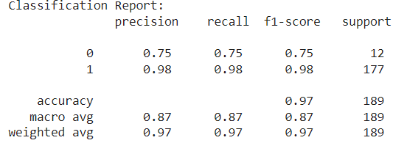 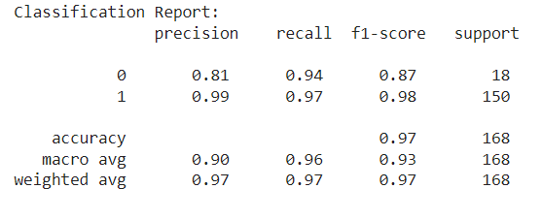

**Random Forest**

**Fig. 2A** *Feature Importance for Random Forest on NY and DMV*

**NY: DMV:**

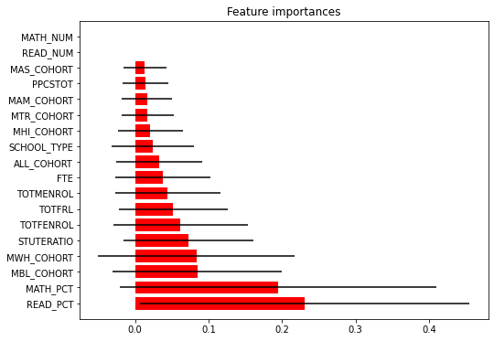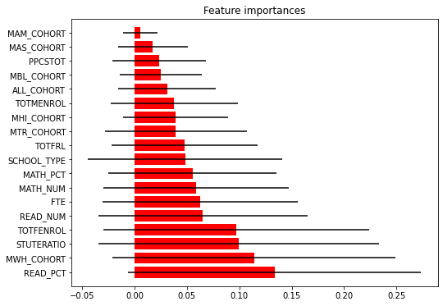

**Logistic Regression**

**Fig. 3A** *Ridge, Lasso, and Logistic Regression R2 Chart for NY and DMV*

**NY DMV**

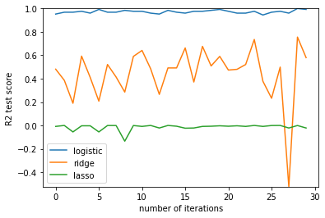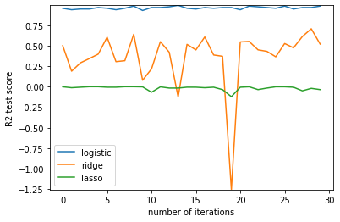

**Neural Networks**

**Fig. 4A** *Accuracy Scores for Neural Networks on NY and DMV*

**NY DMV**

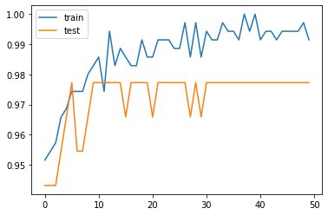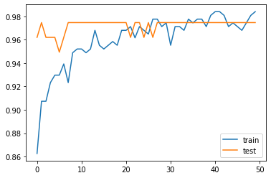

**Fig. 5A** *Loss Scores for Neural Networks on NY and DMV*

**NY DMV**

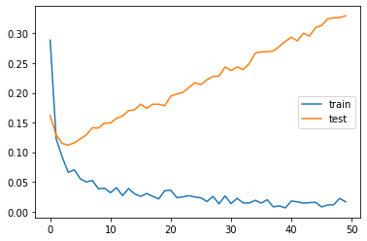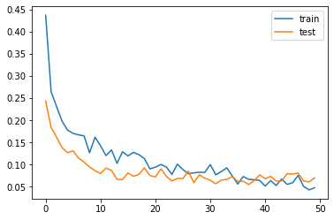

**Clustering:**

**Fig. 6A** *Silhouette Scores for NY and DMV*

**NY DMV**

1. G.I. Bill of 1944.
2. National Defense Education Act of 1958
3. NCES, Trends in High School Dropout and Completion Rates in the United States, <https://nces.ed.gov/programs/dropout/ind_03.asp#:~:text=Data%20from%20the%20Current%20Population,credential%2C%20such%20as%20a%> retrieved on December 10, 2021